Blockchain PSIG Call Notes
6 May 2021

Attendees
- Mike Bennett
- Rob Nehmer
- Ambrose Kam
- Bobbin Teegarden
- Nick Stavros
- Frederic de Vaulx

Agenda
- General updates
- Landscape
  - Money / exchanges etc.
  - Layer model

Meeting Notes

General Updates

Paper on Coin Exchanges
Paper that Rob mentioned: how you bid on the coin exchanges when trading. RN contacted the author – he was re-writing, has now sent.
How to post this? E.g. wiki.
- Wiki is a good idea
- Now we need to figure out where
- Public v private
  - This one should be in the private

Wiki Usage – Page Settings
Page created in the private area
blk:private: is the way to name a file to be in the private area.
Likewise for public: blk:public
File on its way (PDF)

Landscape Notes
Some pointers on the money stuff:
- IOTA Wallet
- Tether

Example: IOTA Wallet: Buying a thing
Method (from 2018):
- Go to an exchange (Coinbase, Binance)
  - Put some USD in
    - Various ways of doing that
  - Turn that into a ‘tether’ currency
    - Coinbase has its own called USDC
    - Others – USDT
      - Called a ‘Stablecoin’ – see below
    - Now you have USDT at the Exchange
  - Exchange USDT tokens for your desired crypto e.g. IOTA
    - Now you have MIOTA at the exchange
  - Open your wallet
    - Function called ‘receive funds’
      - Shows you a funny string and a QR Code
      - These are something
        - ‘address’ or something else
        - This is a thing specific to you and your wallet, against which the ownership of crypto token cab be registered
          - Registered on the DLT
      - Copy that code
  - Back in the exchange
      - In the exchange you past that code somewhere to ‘send funds’
    - Then the exchange moves the amount (however much you choose)
    - Into your wallet
  - You now have X number of MIOTA in your wallet.

Simpler: using a wallet
You want someone to send you some money
2 functions exist:
- Send funds
- Receive funds
Go to a function called Receive Fund
It creates a string and a QR code.
You send that to the person
They use that to send the funds to your wallet

Knowledge: Where is the Money
So there are ways for money to be:

Exchanges References
Coinbase:
https://www.coinbase.com/
Binance
https://accounts.binance.com/en/register?ref=Y14AUTCA
Bitfinex
https://www.bitfinex.com/
Bittrex
https://global.bittrex.com/

Examples: IOTA Chrysalis Migration
Gives us some useful pointers to the ‘where is the money?’ questions:

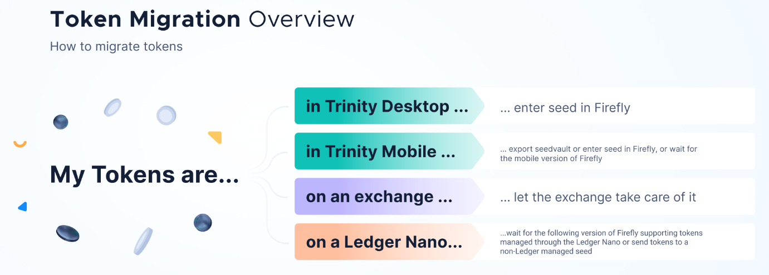

Conclusions on 'Where is the Money?'
In IOTA example, There are 3 kinds of place where your ‘money’ may reside:
- Wallet
- Exchange
- Ledger
Ledger Nano is a hardware wallet. Ledger is the company name.
So this is not a ledger-based i.e. account based scenario. It is a Wallet.
So there are just 2 kinds of thing:
- Wallet
- Exchange

Question: What is the actual ecosystem
i.e. are there people sending and receiving these things, are they accepted for payment and so on.
Other consortia may differ.
Probably proofs of concept for future business application.
May be some business applications?
No obvious retail places to buy coffee etc. (as there are some for Bitcoin)
- Add this to RFI Questions.
Wallets compatibility with ERC20 would probably work on any coin that uses ERC20. Probably.
Ecosystem: recall that e.g. IOTA Foundation, Ethereum, Hyperledger curate a thing that others use to develop a thing that someone might develop a business facing application from.

Terms

Define Stablecoin
A crypto currency token or coin pegged to some fiat currency or some other traded asset e.g. metals, other financial instruments.

Kinds of Stablecoin
Pegged to a currency or something else.
- What kind of something? …

Tether:
As cited in article (NY State case?)
Every tether is always 100% backed by our reserves, which include traditional currency and cash equivalents and, from time to time, may include other assets and receivables from loans made by Tether to third parties, which may include affiliated entities (collectively, “reserves”)
On the website today 6 May 2021:
Every Tether token is always 100% backed by our reserves, which include traditional currency and cash equivalents and, from time to time, may include other assets and receivables from loans made by Tether to third parties, which may include affiliated entities (collectively, “reserves”).
(same words + ‘token’)
Followed by (on website):
Every Tether token is also 1-to-1 pegged to the dollar, so 1 USD₮ Token is always valued by Tether at 1 USD.

Definitions
What is an audit – what auditing standards are used?
What did they represent to the auditor, that the auditor confirmed?
What is ‘from time to time’

Tether Story
Main story 2018
What is the position now / since?
Semantics implications:
- Money
- Bank

Article References:
2021 article(s) (not crypto-friendly)
https://crypto-anonymous-2021.medium.com/the-bit-short-inside-cryptos-doomsday-machine-f8dcf78a64d3
2019 (about 2018 events)
https://www.kalzumeus.com/2019/10/28/tether-and-bitfinex/
https://www.bloomberg.com/opinion/articles/2019-04-26/things-got-weird-for-stablecoin-tether
More Authoritative sources
https://en.wikipedia.org/wiki/Tether_(cryptocurrency)
https://www.investopedia.com/terms/t/tether-usdt.asp
https://tether.to/
current status?
https://www.valuethemarkets.com/2021/04/13/tether-usdt-stablecoin-crush-bitcoin/

